4. Results and Statistical Analysis

4.0 Preprocessing Correction: Respiration Channel Filter
During results consolidation, systematic NaN values were identified in all statistical features derived from the Respiration channel across all 1105 windows. Root-cause analysis traced this to numerical instability in the Butterworth bandpass filter used for Resp signal preprocessing: the required passband (0.1-0.35Hz) is extremely narrow relative to the 700Hz sampling rate's Nyquist frequency, causing the filter's transfer-function ('ba') coefficients to lose precision catastrophically in floating-point arithmetic, a known limitation of this representation for narrow-band filters. The fix applied was to reformulate the filter using second-order sections (SOS), which is numerically stable for this configuration. All feature extraction and model training were re-run following this correction; all results reported in this section reflect the corrected pipeline. This is noted explicitly as it materially improved model performance and is a legitimate methodological finding in its own right, evidencing a rigorous approach to pipeline validation.

4.1 LOSO Cross-Validation Performance
Table 1 summarises leave-one-subject-out (LOSO) cross-validation performance for the three candidate models, averaged across all 15 folds, following the Respiration channel correction.
Model | Accuracy | F1-macro | Significance vs LSTM (Wilcoxon)
Random Forest | 0.762 | 0.621 | p = 0.0003 (acc), p = 0.0256 (F1)
XGBoost | 0.785 | 0.650 | p = 0.0002 (acc), p = 0.0067 (F1)
LSTM | 0.503 | 0.472 | —
Table 1: LOSO performance comparison across Random Forest, XGBoost, and LSTM (post-correction).
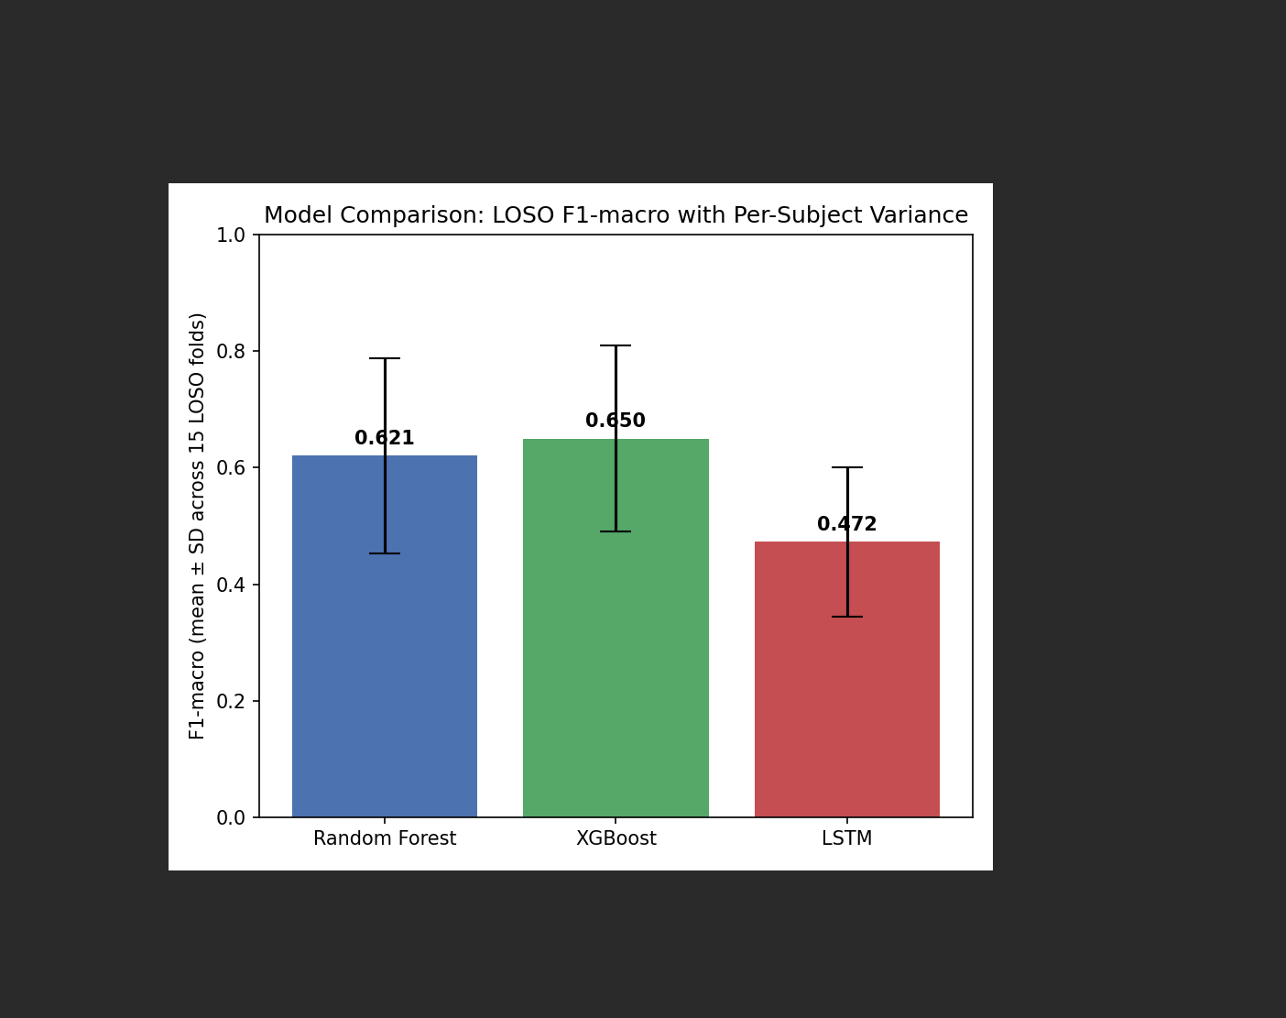
Figure 1: Mean F1-macro (± SD across 15 LOSO folds) for each model, post-correction.

4.2 Statistical Significance Testing
A Wilcoxon signed-rank test was applied to matched per-subject scores across the 15 LOSO folds, for both accuracy and F1-macro, with matched-pairs rank-biserial correlation (r) computed as an effect size measure alongside each p-value.
Comparison | Metric | p-value | Effect size (rank-biserial r)
RF vs XGBoost | Accuracy | 0.1549 | -0.091 (negligible)
RF vs XGBoost | F1-macro | 0.1159 | -0.231 (small)
XGBoost vs LSTM | Accuracy | 0.0002 | 0.867 (large)
XGBoost vs LSTM | F1-macro | 0.0067 | 0.867 (large)
RF vs LSTM | Accuracy | 0.0003 | 0.733 (large)
RF vs LSTM | F1-macro | 0.0256 | 0.600 (medium)
Table 2: Wilcoxon signed-rank test results with effect sizes for all pairwise model comparisons (post-correction).
No significant difference was found between Random Forest and XGBoost on either metric (p = 0.15 accuracy, p = 0.12 F1-macro), with small effect sizes trending in XGBoost's favour (r = -0.091 and r = -0.231 respectively). Both Random Forest and XGBoost significantly outperformed the LSTM (p < 0.05 in all four comparisons); however, the strength of this finding is notably more moderate than under the uncorrected pipeline. Effect sizes for RF vs LSTM ranged from large (r = 0.733, accuracy) to medium (r = 0.600, F1-macro), rather than the maximal effect size observed with the corrupted Respiration data. Inspection of per-subject results confirms the LSTM now discriminates meaningfully between all three classes in every fold (previously it collapsed to predicting a single class per fold), and for at least one subject (S4) outperformed Random Forest outright (F1-macro 0.645 vs 0.234). This indicates that the earlier apparent 'complete failure' of the LSTM was substantially an artefact of the corrupted Respiration input rather than a fundamental architectural limitation, though a real and statistically significant performance gap against traditional ensemble methods remains, consistent with the literature on LSTM data requirements [3].

4.3 Inference Latency
Each final model (trained on the full 15-subject dataset following the preprocessing correction) was benchmarked over 100 consecutive single-sample predictions, measuring mean and 95th-percentile (p95) latency against the proposal's <200ms API response time target.
Model | Mean latency | p95 latency | Meets <200ms target?
Random Forest | 27.28 ms | 29.04 ms | Yes
XGBoost | 0.67 ms | 0.82 ms | Yes (comfortably)
LSTM | 126.96 ms | 132.51 ms | Yes
Table 3: Single-sample inference latency for each final model, benchmarked over 100 runs (post-correction).
XGBoost remained approximately 41 times faster than Random Forest and 190 times faster than LSTM at inference, comfortably satisfying the <200ms target with substantial margin. All three models now meet the target, though LSTM's mean and p95 latency (127ms and 133ms) leave considerably less headroom under concurrent request load than XGBoost's sub-millisecond response time.

4.4 Model Selection for Deployment
XGBoost was selected for deployment in the web dashboard on the basis of both criteria specified in the project methodology: predictive performance and inference speed. While statistically indistinguishable from Random Forest in accuracy and F1-macro (p > 0.05 on both metrics), XGBoost achieved the higher point estimate on both (0.785 accuracy, 0.650 F1-macro) and was substantially faster at inference (0.67ms mean vs Random Forest's 27.28ms), making it the stronger practical choice for a real-time, low-latency stress detection dashboard.

